ONLINE TRAINING
TRAINING DATE
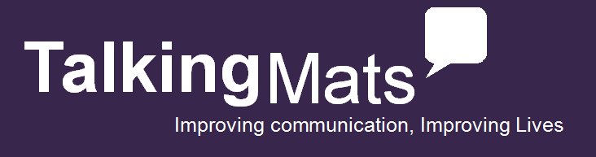

Basic requirements to apply for the course:
- You will require a PC or laptop with internet access (please note most sections of the course can also be completed using a tablet)
- A device to upload photos or videos during the course
- Audio output (speakers or headphones)
Choose the training package for you which will include one of the following digital resources
(The digital will work on your iPad, Android or through a web browser on your computer)
- Please click a box on the resource most suited to your client group to accompany your training
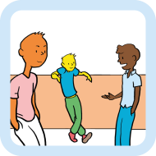
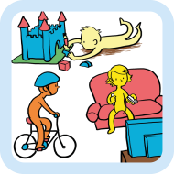
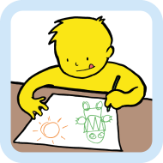
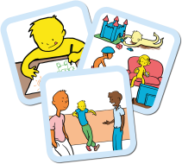
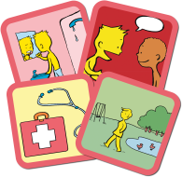
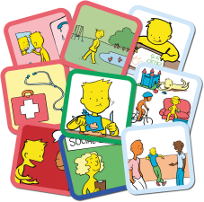
Secondary
Aged 12+
Topics – My body & skills, my wider world, what I do & my support

Primary
Aged 5-12
Topics – My body & skills, my wider world, what I do & my support

Early Years
Aged 3-7
Topics – My body & skills, my wider world, what I do & my support

Consulting Children & Young People bundle
A comprehensive bundle to explore well-being across different ages
£250
+VAT
£190
+VAT
£190
+VAT
£190
+VAT

£360
+VAT
Talking Mats best value bundle
A complete set to support communication with children & adults including Health & Well-being, Consulting Children & Young People, Social Care, Eating & Drinking

Health & Well-being bundle
A comprehensive bundle including Looking after yourself, Communication, Health, Leisure & Environment
£250
+VAT

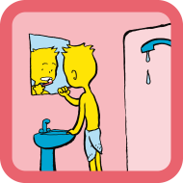
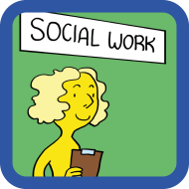
Communication
Topics – Expression, understanding, relationships, learning & thinking

Health
Topics - Health, Mobility & Coping

Looking After Yourself
Topics - Self-care, domestic life, work & education

£190
+VAT
£190
+VAT
£190
+VAT

£190
+VAT
Social Care
Topics – You, activities & where you live

Name and Job Role
Email for logon
Client Group
Telephone
Address: |  |  | Invoice Address and email if different:
Order No (if applicable)
Vat No (if applicable)
How did you hear about Talking Mats
To apply please return a registration form to the address or email below
Talking Mats Ltd. Stirling University Innovation Park, Stirling, FK9 4NF, Tel - 01786 479511, info@talkingmats.com
www.talkingmats.com

Please note there will be a late payment fee of £30 for any overdue assignments

