TRAINING LOCATION
TRAINING DATE
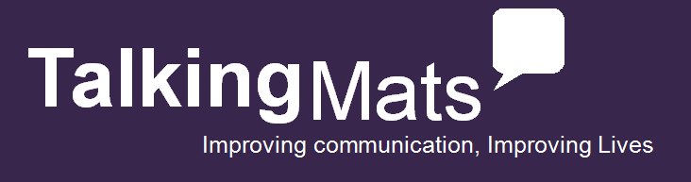

Choose the training package for you with the option of an original bundle, digital bundle or training only.
(The original resource uses a physical mat and symbols on card while the digital will work on your iPad, Android or through a web browser on your computer)
- Please mark in a box your required option
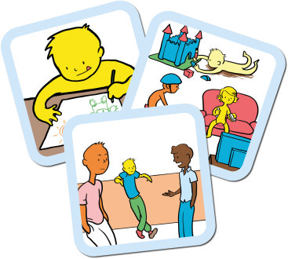
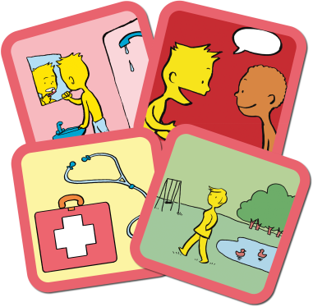
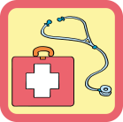
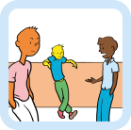
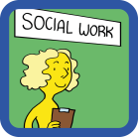
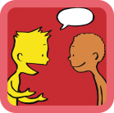
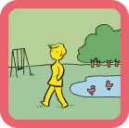
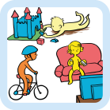
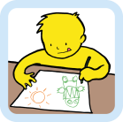
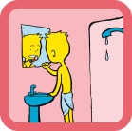

£175
+ VAT
Talking Mats Training only
Learn how to use a powerful communication tool which evidences person-centred planning.

Talking Mats Training with Consulting Children & Young People bundle
A comprehensive bundle to explore well-being across different ages

£360
+ VAT
Talking Mats Training with Best Value Bundle
A complete set of resources to support communication on a comprehensive range of topics for children and adults including Health & Well-being, Consulting Children & Young People, and Social Care.

£250
+ VAT
Talking Mats Training with Health & Well-being bundle
A comprehensive bundle to reflect on all aspects of health & well-being
£250
+ VAT

Name and Job Role
Original, Digital or Training only
Client Group
Telephone
Email
Address: |  | Invoice Address and email if different:
Order No (if applicable)
Vat No (if applicable)
Any special requirements
How did you hear about
Talking Mats
To apply please return a registration form to the address or email below
Talking Mats Ltd. Stirling University Innovation Park, Stirling, FK9 4NF, Tel - 01786 479511, info@talkingmats.com
www.talkingmats.com

