|  |  |
| --- | --- |
| **TRAINING LOCATION** |  |
| **TRAINING DATE** |  |

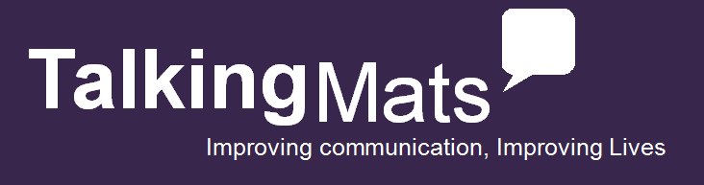

**Choose the training package for you with the option of an original bundle in card format, digital bundle, both or training only.**

(The original resource uses a physical mat and symbols on card while the digital will work on your iPad, Android or through a web browser on your computer)

* 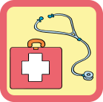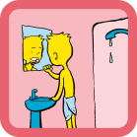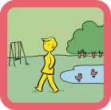**Please mark in a box your required option**

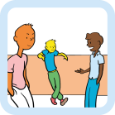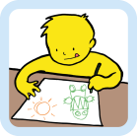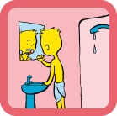

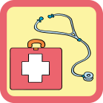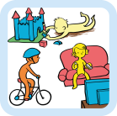

£175 + VAT

£250 + VAT for

card **or** digital

……………………………

£350 + VAT for flexibility of **both**

card & digital

£250 + VAT for

card **or** digital

……………………………

£350 + VAT for flexibility of **both**

card & digital

£360 + VAT for

card **or** digital

……………………………

£500 + VAT for flexibility of **both**

card & digital

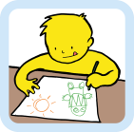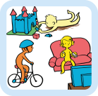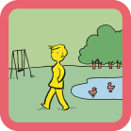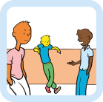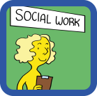

**Talking Mats Training with Consulting Children & Young People bundle**

A comprehensive bundle to explore well-being across different ages.

**Talking Mats Training with Health & Well-being bundle**

A comprehensive bundle to reflect on all aspects of health & well-being.

**Talking Mats Training only**

Learn how to use a powerful communication tool which evidences person-centred planning.

**Talking Mats Training with Best Value Bundle**

A complete set of resources to support communication on a comprehensive range of topics for children and adults including Health & Well-being, Consulting Children & Young People, and Social Care.

|  |  |  |
| --- | --- | --- |
| Name and Job Role |  | |
| Card, Digital, Both or Training only |  | |
| Client Group |  | |
| Telephone |  | |
| Email |  | |
| Address: | | Invoice Address and email if different: |
| Order No (if applicable) |  | |
| Vat No (if applicable) |  | |
| Any special requirements |  | |
| How did you hear about  Talking Mats  **To apply please return a registration form to the address or email below**  **Talking Mats Ltd. Stirling University Innovation Park, Stirling, FK9 4NF, Tel - 01786 479511, info@talkingmats.com**  **www.talkingmats.com** |  | |